
QUALITY ALERT

Customer: United Date: April 18, 2024
Die: 15137 Colour: ALL COLOURS
Type of Complaint: United REJECT

Q.A # Q.I.R # CUSTOMER NCR #

Description: United REJECTED Material was deform/ collapse causing the punch CUT not clean.
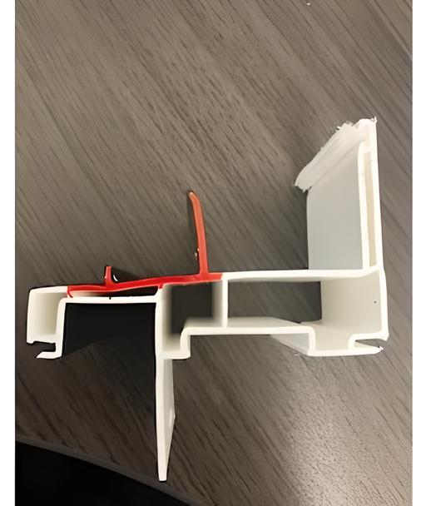

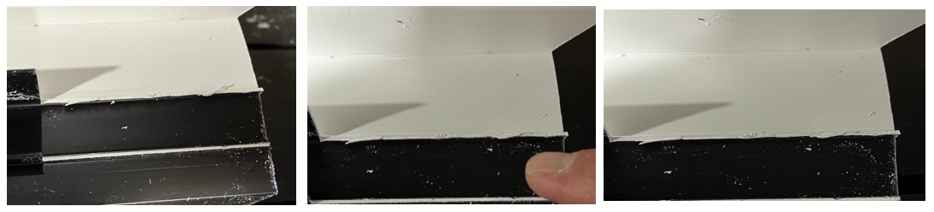

PLEASE MAKE SURE GOOD MATERIAL BEFORE PACKING

BY SIGNING BELOW, YOU ACKNOWLEDGE THE PROBLEM ABOVE AND AGREE TO MONITOR THIS ISSUE IN FUTURE PRODUCTION RUNS.
DAY SHIFT |  | AFTERNOON SHIFT |  | NIGHT SHIFT
NAME | SIGNATURE | NAME | SIGNATURE | NAME | SIGNATURE

